Biblical Prophecy of Scientific Findings

As Recorded in Genesis 1

As science has continued to make discoveries about the transformation of the earth and life on the earth in eons past, it has become more clear that there are strong parallels between the descriptions of science and the descriptions in the Bible. These descriptions in the Bible have strong parallels with the scientific findings. But the Bible does not use the same types of descriptions that modern science uses for describing events. The descriptions in the Bible seem to use a more prophetic tone, mixing facts with metaphors.
As an example of how prophecy is used in the Bible, we can look at Psalm 22. Psalm 22 describes the horrors of crucifixion and is prophetic of Jesus’ death on the cross. Psalm 22 also says that “strong bulls of Bashan encircle me” and “Roaring lions that tear their prey open their mouths wide against me”. Those events concerning bulls and lions did not literally happen at the crucifixion, but they were metaphors of the injustice and violence that was done against Jesus in His crucifixion.
In a similar way that metaphors have been used in messianic or historical prophecies in the Bible, then metaphors seem to be used in Genesis 1 as well. For example, the phrase, “and there was evening and there was morning, the first day” (or second day, etc.), can be seen as a metaphor for a time of ending and beginning - a new phase, a new period. On the other hand, there are also many descriptions in Genesis 1 and other Biblical passages (e.g., Job 38-39) that clearly parallel scientific findings. So, instead of messianic or historical prophecies in the Bible, we now have prophecies that we see (in our age of science) to closely parallel our scientific findings. And again, this mixture of fact and metaphor in these passages concerning science is why it seems appropriate to call these passages Biblical prophecies.

The following pages provide some simple visualizations, a “picture book” of sorts, for how these prophecies of science have been used in Genesis 1. Passages from Genesis use the New International Version (NIV).

In the beginning God created the heavens and the earth. Now the earth was formless and empty, darkness was over the surface of the deep, and the Spirit of God was hovering over the waters.
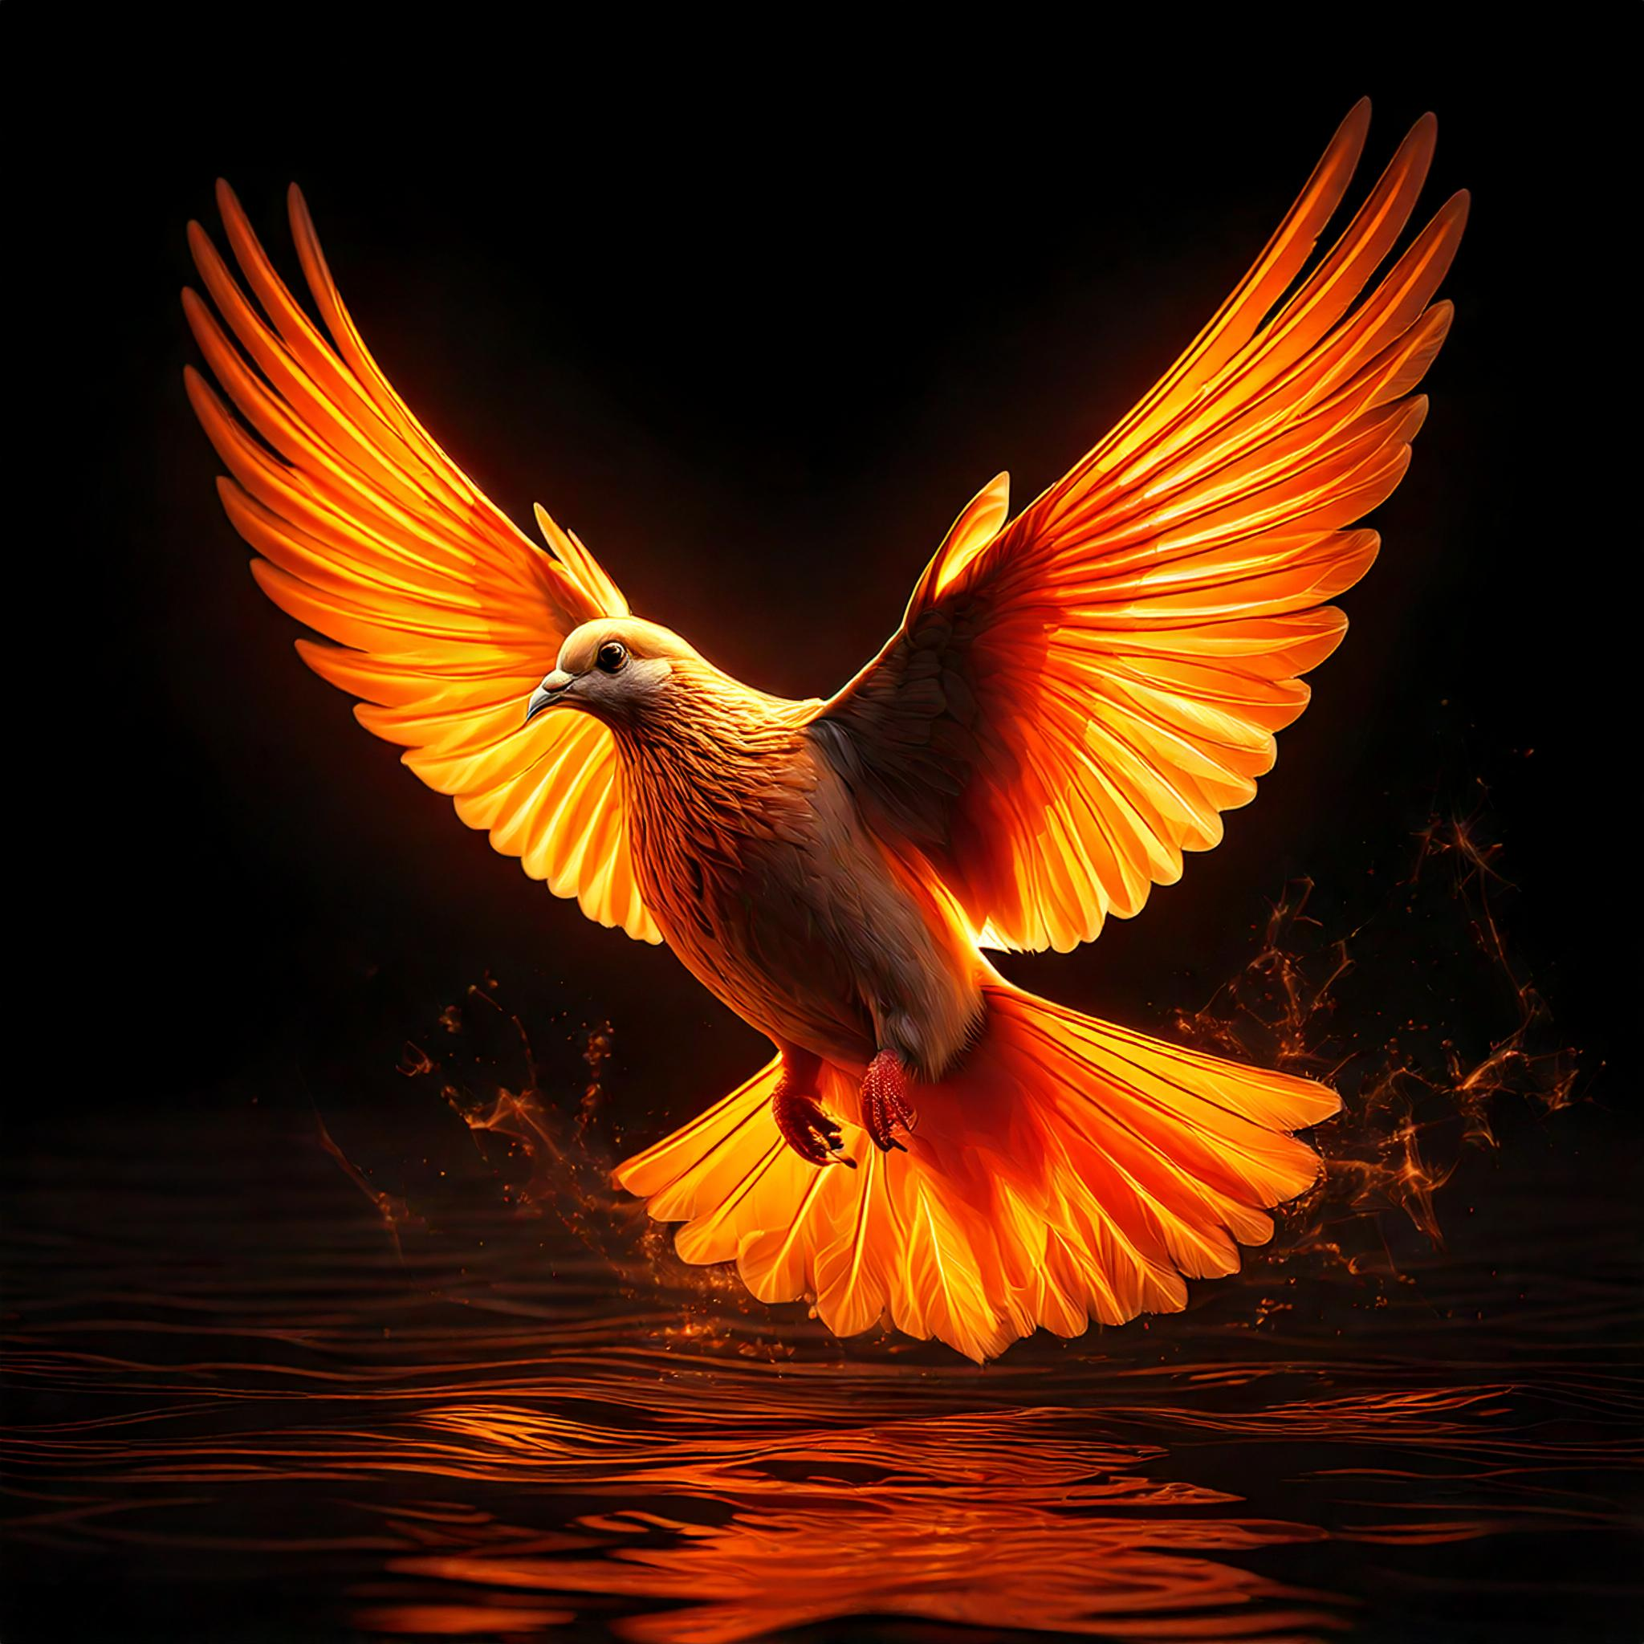
The Spirit of God hovering over the waters of the primordial earth with darkness above

And God said, “Let there be light,” and there was light. God saw that the light was good, and he separated the light from the darkness. God called the light “day,” and the darkness he called “night.” And there was evening, and there was morning—the first day.
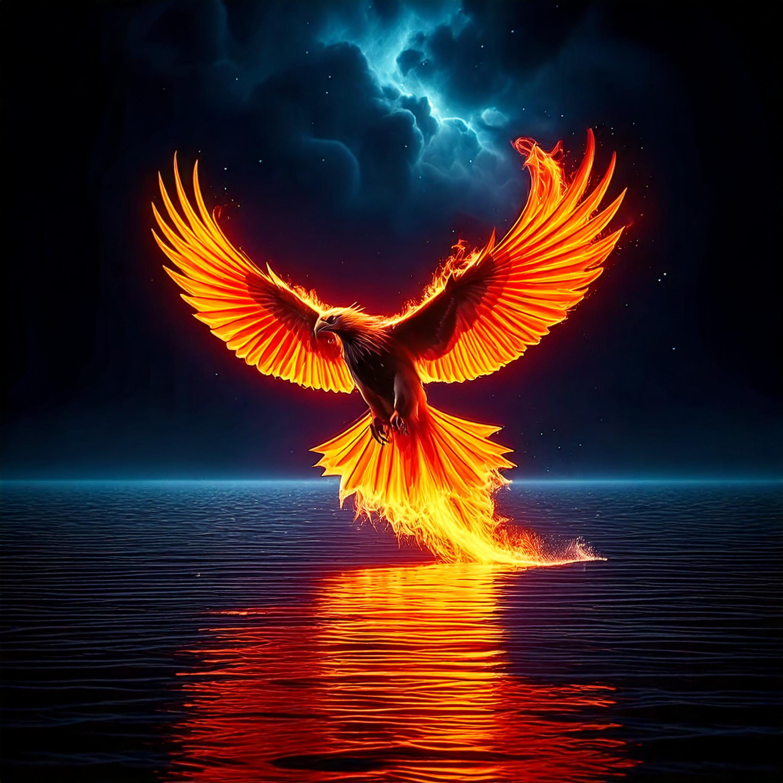
Light first breaks through the darkness over the earth. There is still no atmosphere, though.

And God said, “Let there be a vault between the waters to separate water from water.” So God made the vault and separated the water under the vault from the water above it. And it was so. God called the vault “sky.” And there was evening, and there was morning—the second day.
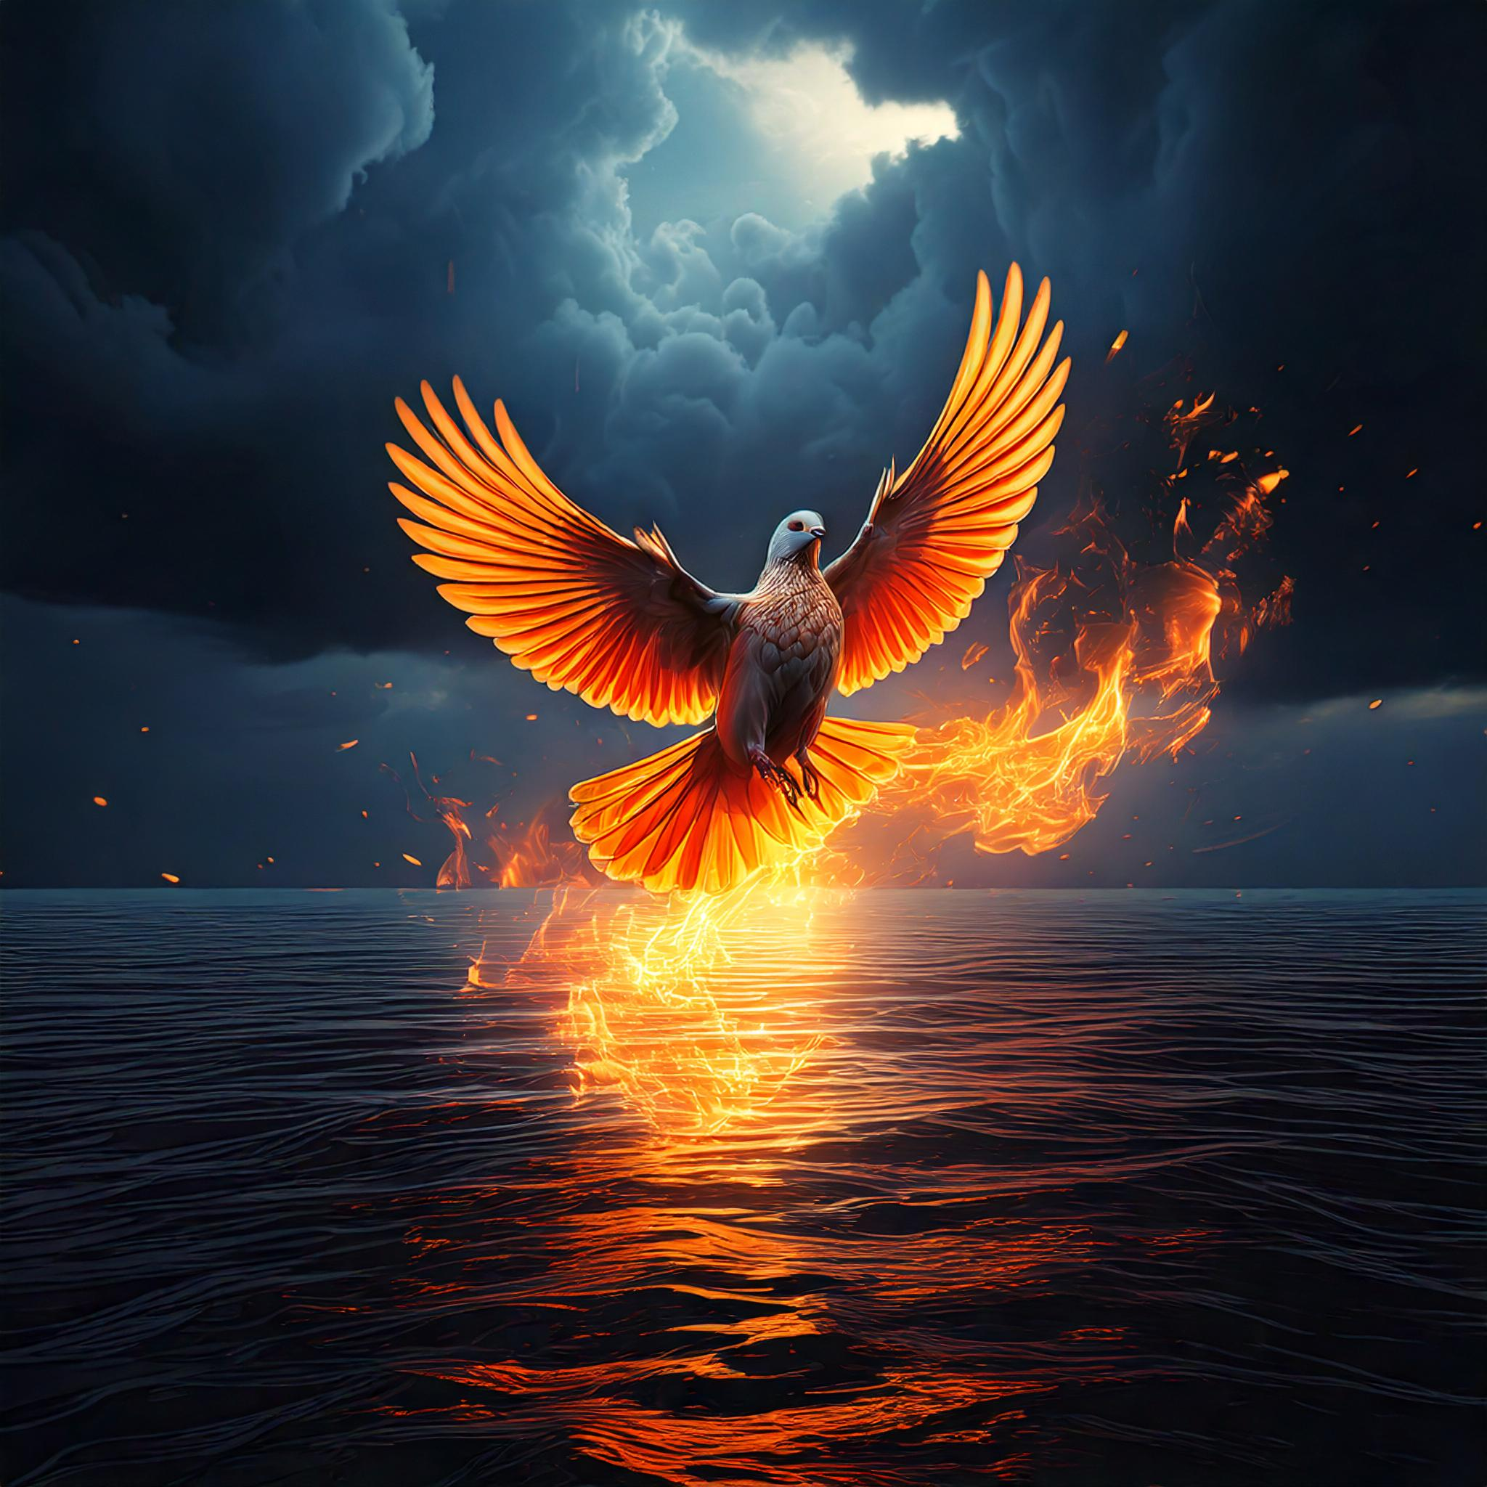
The atmosphere or “sky” forms between the water covered earth and the clouds above.
And God said, “Let the water under the sky be gathered to one place, and let dry ground appear.” And it was so. God called the dry ground “land,” and the gathered waters he called “seas.” And God saw that it was good.

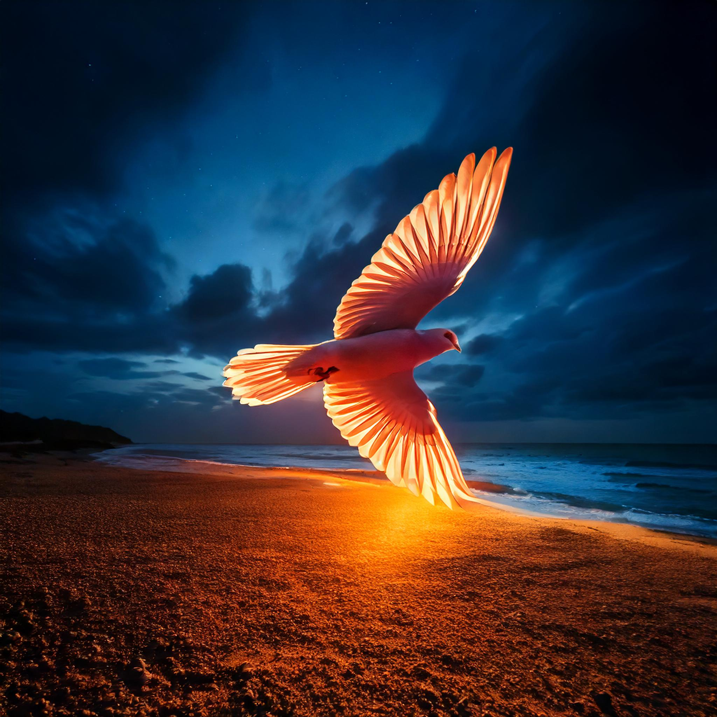
The land appearing amidst the seas, still under the dark cloud cover
Then God said, “Let the land produce vegetation: seed-bearing plants and trees on the land that bear fruit with seed in it, according to their various kinds.” And it was so. The land produced vegetation: plants bearing seed according to their kinds and trees bearing fruit with seed in it according to their kinds. And God saw that it was good. And there was evening, and there was morning—the third day.
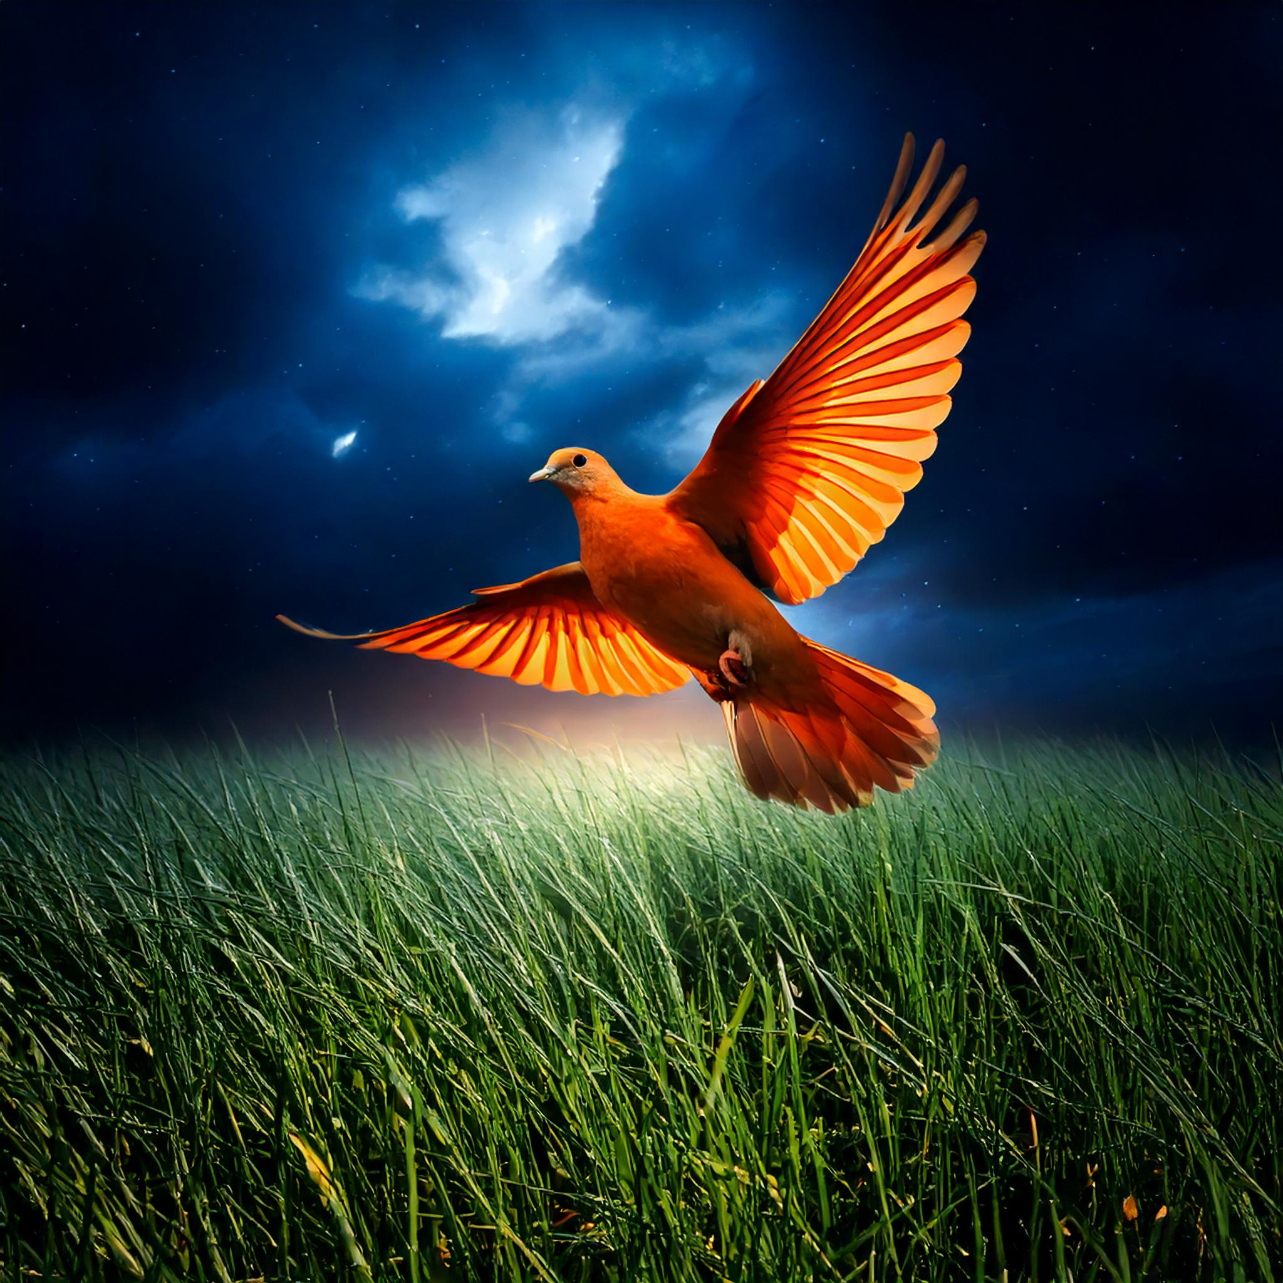
The land producing vegetation
And God said, “Let there be lights in the vault of the sky to separate the day from the night, and let them serve as signs to mark sacred times, and days and years, and let them be lights in the vault of the sky to give light on the earth.” And it was so.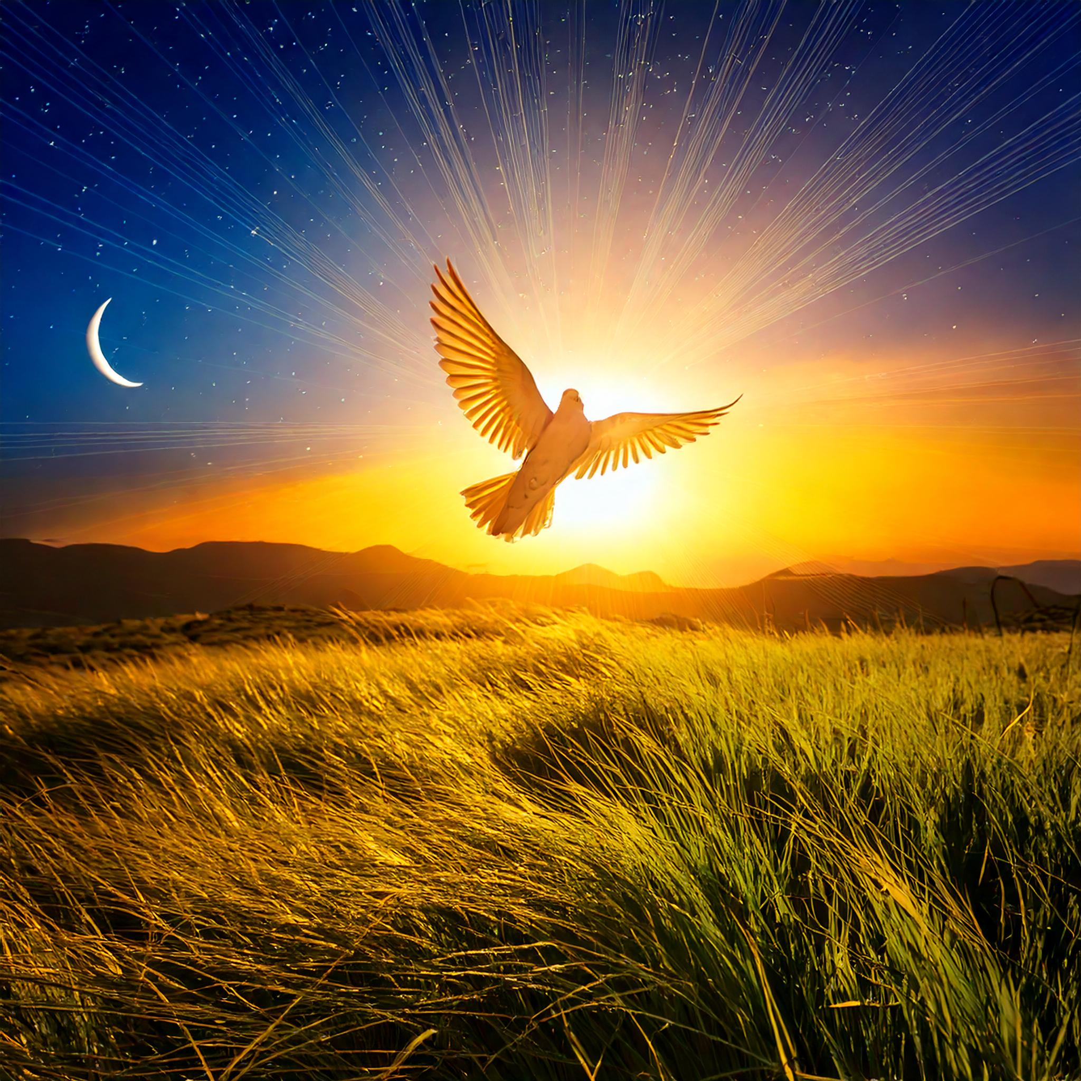
The dark clouds give way to a clear atmosphere where the sun, moon, & stars are visible

God made two great lights—the greater light to govern the day and the lesser light to govern the night. He also made the stars.
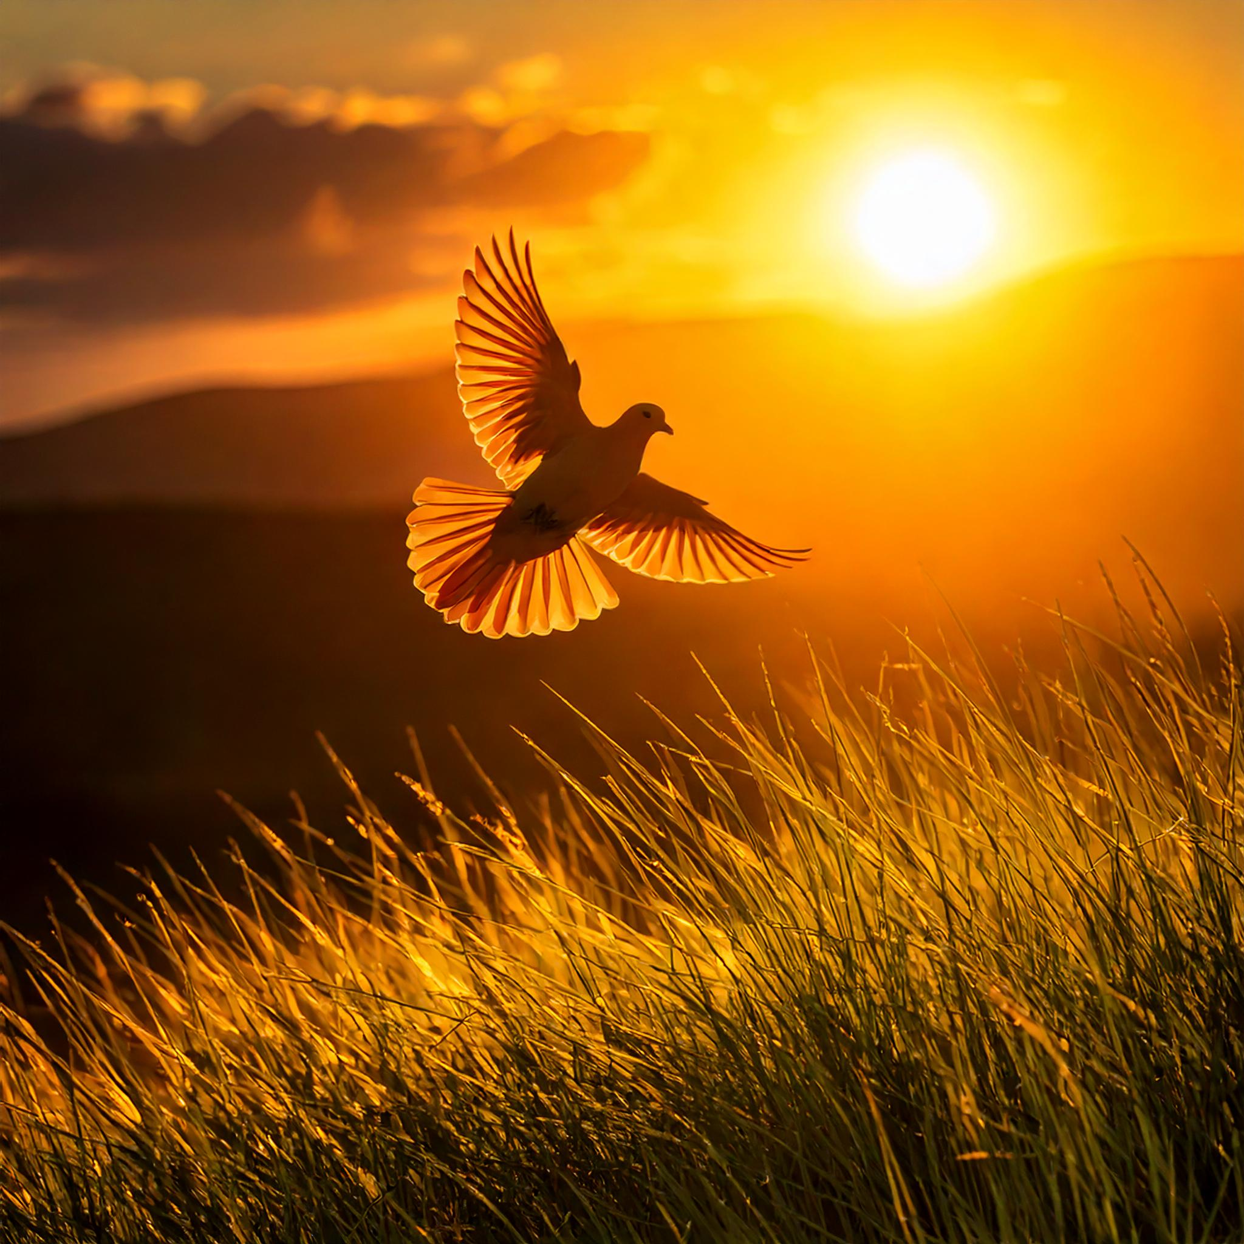
The sun – the greater light – appears to govern the day

God set them in the vault of the sky to give light on the earth, to govern the day and the night, and to separate light from darkness. And God saw that it was good. And there was evening, and there was morning—the fourth day.

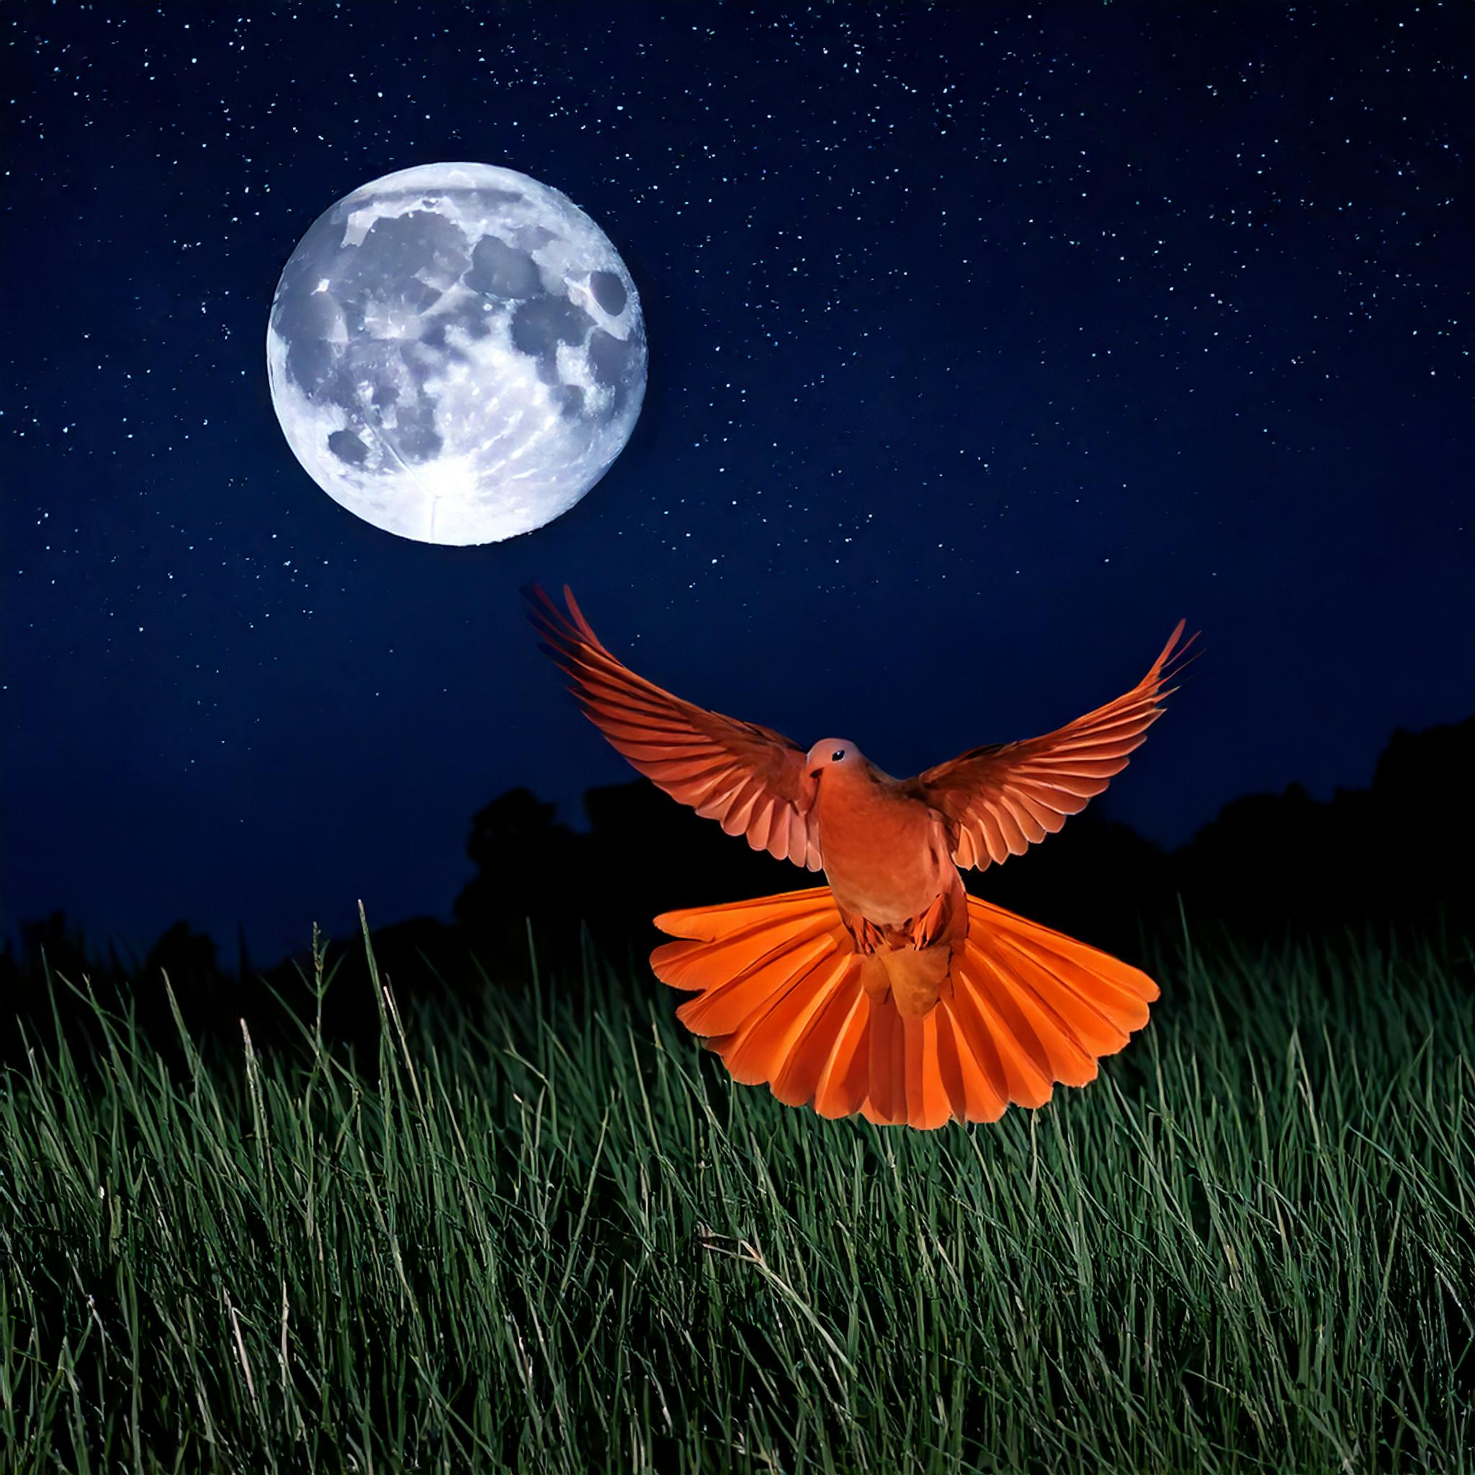
The moon – the lesser light – appears to govern the night, along with the stars

And God said, “Let the water teem with living creatures, and let birds fly above the earth across the vault of the sky.” So God created the great creatures of the sea and every living thing with which the water teems and that moves about in it, according to their kinds, and every winged bird according to its kind. And God saw that it was good. God blessed them and said, “Be fruitful and increase in number and fill the water in the seas, and let the birds increase on the earth.” And there was evening, and there was morning—the fifth day.
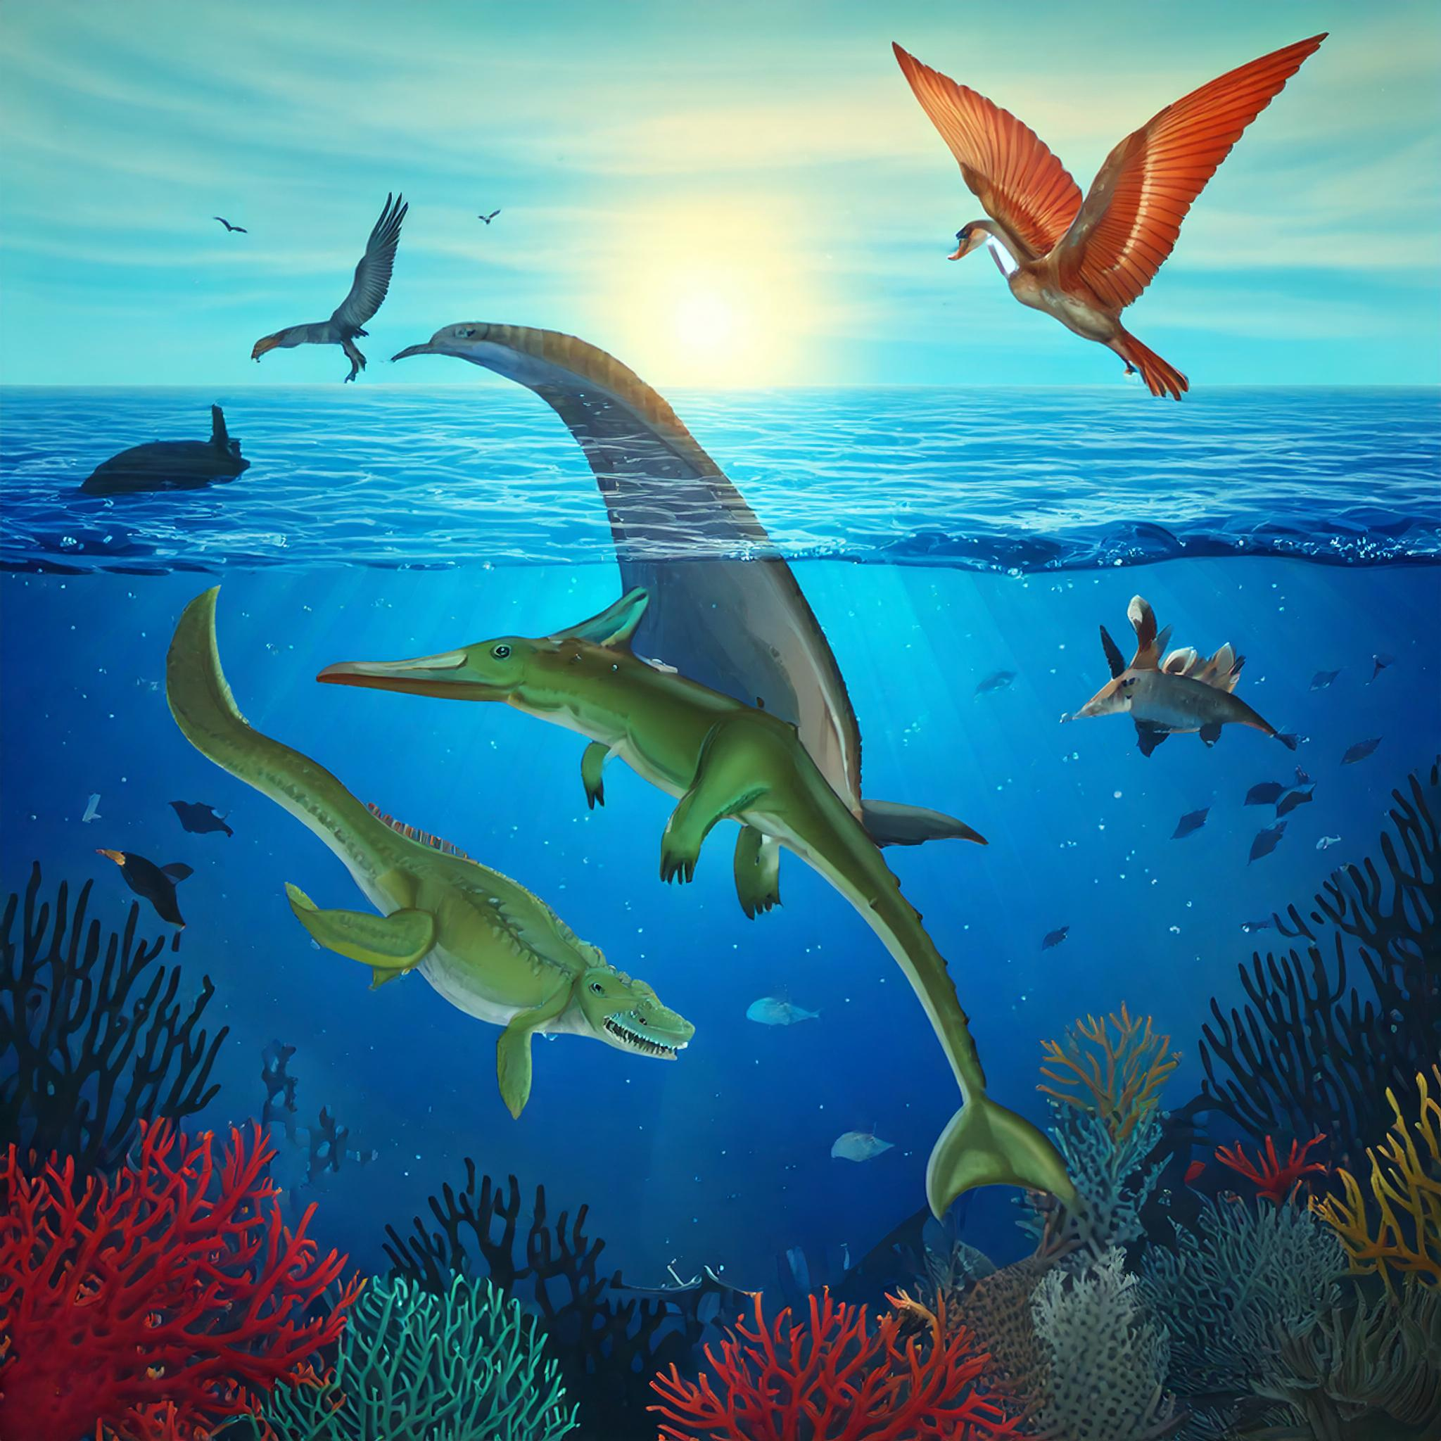
The creation of fish, dinosaurs (the predecessor of birds), and birds
And God said, “Let the land produce living creatures according to their kinds: the livestock, the creatures that move along the ground, and the wild animals, each according to its kind.” And it was so. God made the wild animals according to their kinds, the livestock according to their kinds, and all the creatures that move along the ground according to their kinds. And God saw that it was good.
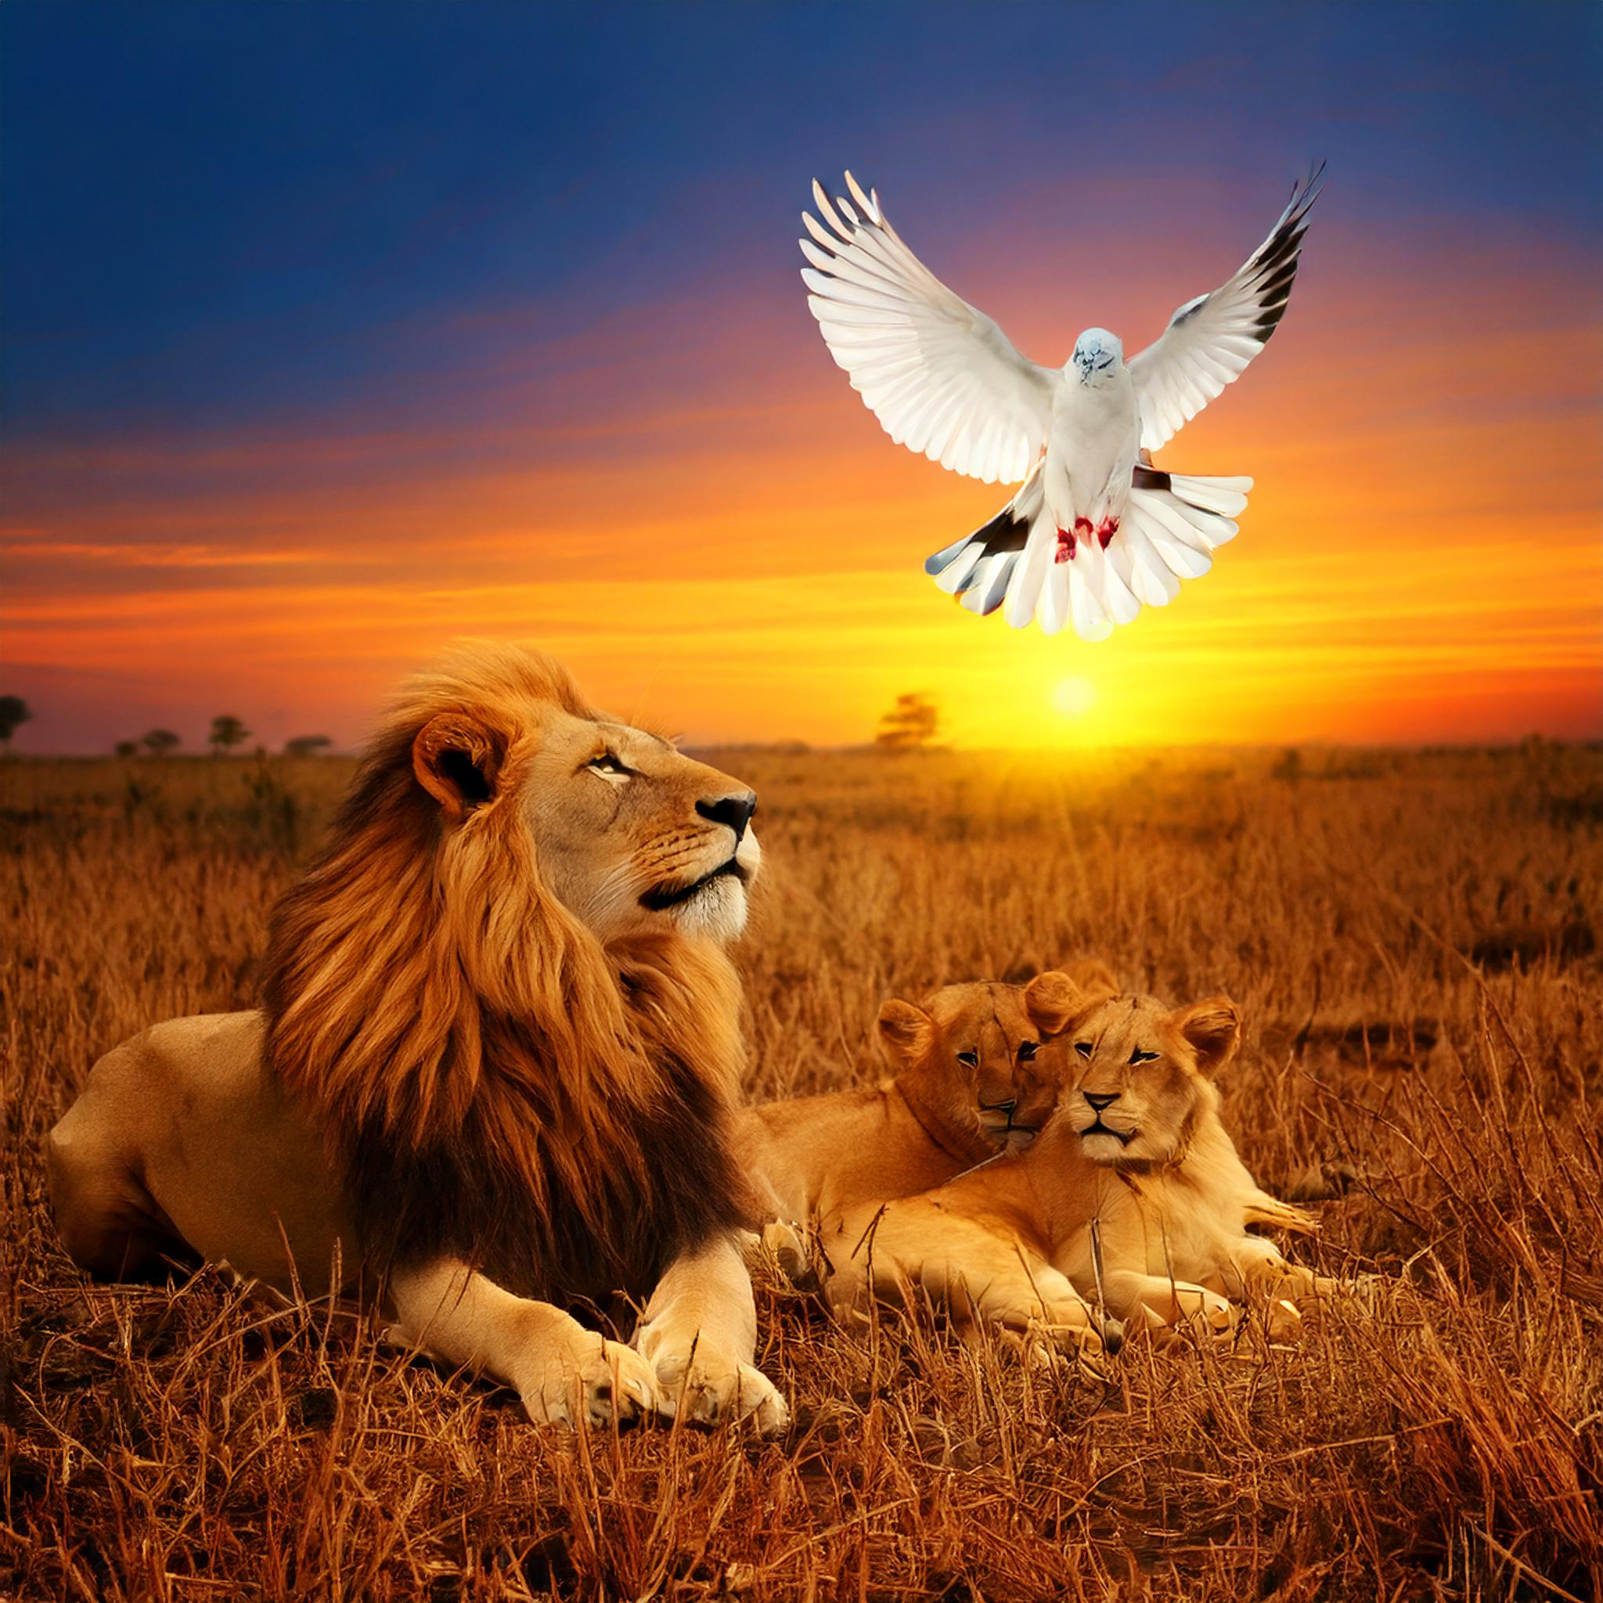

God making mammals – lions, cattle, deer, other livestock
Then God said, “Let us make mankind in our image, in our likeness, so that they may rule over the fish in the sea and the birds in the sky, over the livestock and all the wild animals, and over all the creatures that move along the ground.”
So God created mankind in his own image,
in the image of God he created them;
male and female he created them.

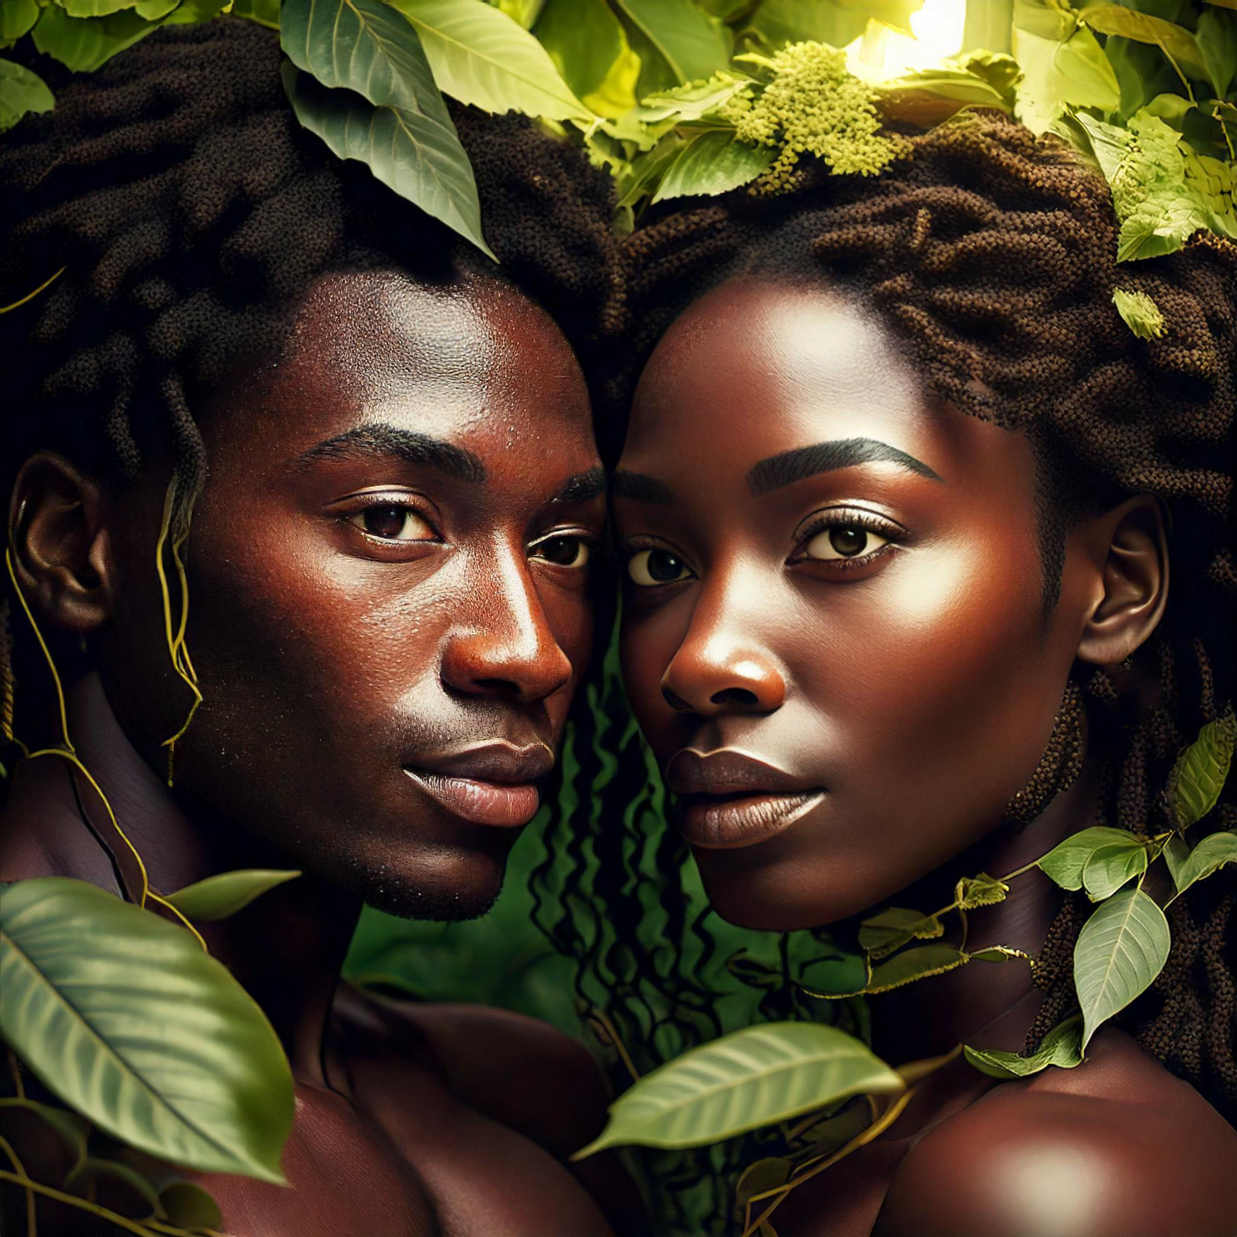
God creates man and woman in His own image
God blessed them and said to them, “Be fruitful and increase in number; fill the earth and subdue it. Rule over the fish in the sea and the birds in the sky and over every living creature that moves on the ground.”
Then God said, “I give you every seed-bearing plant on the face of the whole earth and every tree that has fruit with seed in it. They will be yours for food. And to all the beasts of the earth and all the birds in the sky and all the creatures that move along the ground—everything that has the breath of life in it—I give every green plant for food.” And it was so.
God saw all that he had made, and it was very good. And there was evening, and there was morning—the sixth day.

